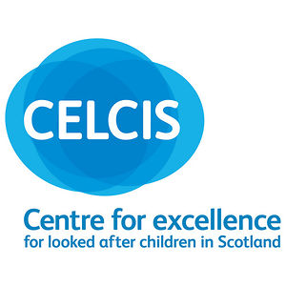

SHRC InterAction on Historic Abuse of Children in Care

Action Plan on Justice for Victims of Historic Abuse of Children in Care

Contents

Background 4
Vision 6
Purpose 6
Outcome 1: Acknowledgement of historic abuse of children in care and effective apologies are achieved. 7
Outcome 2. Accountability for historic abuse of children in care will be upheld, including access to justice, effective remedies and reparation 8
Implementation of the Action Plan 11

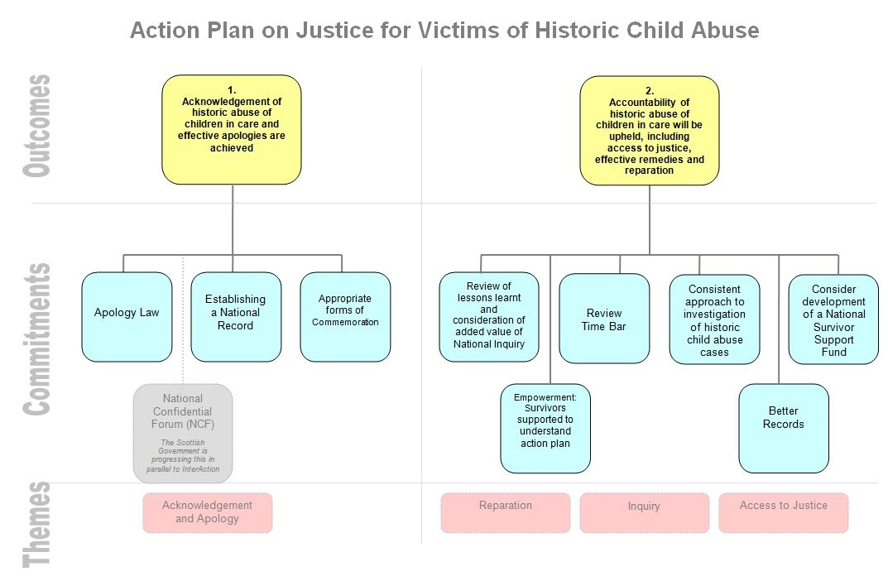

Background
Scotland has taken various steps to address historic abuse of children while in care. On 1 December 2004 the then First Minister Jack McConnell issued an apology on behalf of the people of Scotland for past child abuse in residential care homes. Among other steps the Scottish Government created a National Strategy for Survivors of Childhood Abuse, and following an independent Historical Abuse Systemic Review, announced in 2008 that it would trial a form of truth commission on historic abuse of children in care which was later given the working title, “Acknowledgement and Accountability Forum”. In March 2009 the Scottish Government contracted the Scottish Human Rights Commission (the Commission) to independently develop a Human Rights Framework for the design and implementation of the Acknowledgment and Accountability Forum.
In late 2009, the Scottish Government announced that there would be a pilot confidential forum which would operate from spring 2010 to listen and validate survivors experiences, create a historical record, signpost to services available and test out a confidential committee model. That became known as the Time To Be Heard Forum, which heard from 98 former residents of Quarriers Homes. In response to the report of Time To Be Heard, the Scottish Government announced that it would establish a National Confidential Forum to roll-out the confidential committee model nation-wide.
In 2010 the Scottish Human Rights Commission published a Framework for Justice and Remedies for Historic Abuse of Children in Care (the SHRC Framework). This was based on an analysis of international human rights law, research on the views of survivors and others, and experience in other countries. The Commission undertook this work independently, but under contract to the Scottish Government. In December 2011 Scottish Ministers agreed to engage with an InterAction process (a facilitated negotiation within a human rights framework) to develop an Action Plan to implement the recommendations in the SHRC Framework. This Action Plan for Justice for Victims of Historic abuse of children in care is the result of those InterActions which were prepared in 2012 and held in 2013.

Vision
Everyone has the right to live and be treated with dignity. Sexual abuse and serious physical or emotional abuse or neglect is a breach of the human right to be free from torture or other cruel, inhuman or degrading treatment. Anyone who has been subjected to such abuse has the right to access justice, to effective remedies and reparation (which means repairing the damage done so that, as much as possible, they can be placed in the situation they would have been in had the abuse not taken place). Everyone else who is affected by historic abuse of children in care, whether they are family of victims/survivors, current or former staff in institutions or foster carers, also has human rights which must be upheld. These rights include the right to respect for private and family life, the right to protection of reputation, and the right to a fair hearing.

Recognising and upholding the SHRC Human Rights Framework, participants have identified through a series of InterActions the following areas in which commitments to additional action should be made. This Action Plan is based on the outcomes of two InterActions held on 28 February and 20 June 2013, four “mini-interactions” in May and June 2013 and an open event on 17 June 2013.

The State has responsibility to ensure human rights are respected. This includes upholding the rights of access to justice, effective remedies and reparation for victims/survivors of historic child abuse, and the rights of others affected. Other bodies, whether public, private, voluntary or religious, should contribute to remedies in a manner which is proportionate given the responsibilities they had for the care of those who were abused as children.

Purpose
The purpose of the Action Plan on Justice for Victims of Historic Abuse of Children in Care is to agree and coordinate steps to implement the recommendations in the SHRC Human Rights Framework, on the basis of the outcomes from InterActions.

Outcome 1: Acknowledgement of historic abuse of children in care and effective apologies are achieved.

Context
The human right to an effective remedy includes reparation, one element of which is “satisfaction”. This can include a wide range of measures such as establishing a public historical record, effective apologies and commemorations.

In developing the Human Rights Framework the SHRC looked at the experience of other countries which have adopted Apology Laws which appear to have been successful in facilitating effective and meaningful apologies. A Member’s Bill presented by Margaret Mitchell MSP is currently being considered by the Scottish Parliament.

The Scottish Government is currently establishing a National Confidential Forum, based on the experience of the Time To Be Heard pilot.

Change
In the course of the InterActions, participants broadly agreed on the merits of pursuing an Apology Law. However, it must be carefully thought through in order to ensure that it is meaningful and effective, benefiting the survivor, increasing public awareness and improving future practice. References were also made to National Confidential Forum in all discussions. This was seen as part of the solution, but not the whole solution. Discussion took place regarding ways in which the potential benefit of the NCF could be maximised through changes to legislation as it goes through Parliament. Could this be an opportunity to capture the lived experiences of survivors as part of the national narrative – an oral history in the sense of what happened with the crofters? Or would this perhaps be better captured separately from a NCF?

Commitments
In finalising this Action Plan, parties are encouraged to consider steps which will deliver the following commitments:

  - Barriers to effective apologies from those with historic responsibility for child care in Scotland are increasingly removed, including through a full consideration of the merits of an Apology Law.
  - In establishing the National Confidential Forum, every effort will be made to consider how this might contribute to establishing a national record.
  - Consideration will be given to appropriate forms of commemoration, guided by the views of victims/survivors.

Outcome 2. Accountability for historic abuse of children in care will be upheld, including access to justice, effective remedies and reparation

Context
Accountability for historic abuse of children in care includes ensuring effective access to justice, remedies and reparation. The SHRC Human Rights Framework set out what is expected of the State in terms of each, such as:
- Investigation or inquiry to establish what happened (the facts) and why, to learn systemic lessons and help prevent repetition. Perpetrators of criminal abuse should also be prosecuted.
- Access to justice – civil justice must be accessible to survivors of abuse, and adapted to their needs.
- Reparation – this includes restitution (restoring things that were lost as a result of abuse, such as education or work opportunities), rehabilitation and compensation. What adequate reparation is depends on individual circumstances – it should be proportionate to the harm suffered and the victim/survivor should participate in choosing what is right for them, based on access to reliable information and a range of meaningful choices available to them.

In Scotland there have been a number of public inquiries, such as those in Edinburgh, Fife and at Kerelaw School, and an Historical Abuse Systemic Review. There has not been a national inquiry. There have been a number of prosecutions for historic abuse of children in care and Police Scotland and the Scottish Government are currently developing a protocol for cooperation in the context of the forthcoming National Confidential Forum.

In terms of access to justice the Scottish Government has recently consulted on the “time bar” as part of its review of the law on civil damages.

In terms of reparation, a range of measures of rehabilitation have been taken in the context of the Scottish Government’s Survivor Scotland programme. There is at present no national reparation fund.

Change
During the InterAction process the following views emerged on potential next steps.

Inquiry: There was a very balanced view on the value of an inquiry. Discussions were well-grounded and articulated doubts regarding the value and possible benefits beyond what we have achieved as a result of previous processes. It was felt that we shouldn’t rule out the possible benefits of a national inquiry at this stage but that research was required to determine what we have learned from previous inquiries and what the deficits might be. Based upon the outcome of such research it can then be decided what form an inquiry might take or whether other process would be preferable. Care needs to be taken to ensure that any such process is well designed and contained.
Access to Justice: The justice system is not working for survivors, so we have to try to improve this.
- The time bar is a real barrier to survivors getting access to civil justice. Its consequences include survivors being unable to obtain legal aid, which then impacts on lawyers’ decisions to accept cases. How to address this? Should there be a distinct exception for child abuse victims? Should there be an explicit reference to child abuse in the discretionary criteria used by judges? Would this be enough – judges currently have discretionary powers but don’t use them, so do we need to raise awareness of the issues with them? Perhaps they should be compelled to provide reasons when refusing to exempt cases in order to be more accountable and the subject of appeal?
- Criminal justice – frustration was expressed that there is no nationally consistent approach to investigating historic abuse of children in care and preparing prosecutions. Therefore, there is potentially the need for a specialised unit with a tailored approach to investigating such cases including joint working between the police and those with experience of child care. This would require lawyers, police and those with experience of the care sector to work together to design and administer it. The system must be transparent in order that survivors and others know what to expect.
- A broader perspective on justice – there is a need to think creatively and explore possibilities beyond what already exists. It could be that another forum altogether would be more appropriate for survivors, one that is based on welfare principles. We need to drive forward a culture change with more accountability and empowerment, so that justice is seen as part of the landscape of service improvement.

Reparation: There was a lot of support for a National Reparation Fund or Survivors Support Fund. This needs to be carefully designed with thought given to eligibility criteria and how contributions can be drawn from disparate institutions. While lessons must be learned from other countries, it must nevertheless work in the Scottish context. As was said on the day, “reparation should invoke a ‘sense of family’, belonging and engender healing”. It was stated that the process should be about “helping the person to become a whole human being”, including those “who have been on the wrong side of things as well”.
The following additional points were also raised consistently:
- The need for survivors to have supported decision making and self-determination.
- Dumfries and Galloway, where apologies and ex gratia (no fault) compensation was offered represents an interesting example from which lessons can be learned.
- Records – there are issues related to access and historical management of records. There is also a need to ensure that current record keeping is much better. It was suggested that there should be a dedicated person within every local authority with responsibility for gathering records, rather than it being the responsibility of survivors to travel the country seeking parts of records. CELCIS reported on a project which it is involved with to explore good practice in record keeping.

Commitments
In finalising this Action Plan, parties are encouraged to consider steps which will deliver the following commitments:

1. There should be a review of the lessons learned from previous inquiries and related processes such as the Historical Abuse Systemic Review. The review should consider what added value a National Inquiry on Historic Abuse would have, and should scope the potential costs.

2. The civil justice system should be increasingly accessible, adapted and appropriate for survivors of historic abuse of children in care, including through the review of the way in which “time bar” operates.

3. There should be a nationally consistent and appropriate approach to the investigation and prosecution of offences relating to historic abuse of children in care.

4. Reparation: Options for the development of a national survivor support fund should be explored with all of those affected, including victims/survivors, public, private, voluntary and religious bodies, local authorities and others affected.

5. Empowerment: Survivors should be supported to understand and access the range of measures of in this Action Plan.

6. Records: the outcomes of the ongoing review of record keeping and access to historic records should be considered in the implementation and review of this Action Plan.

Implementation of the Action Plan
This Action Plan should be monitored by the parties and periodic review should be undertaken with the participation of all of those involved. There may be a variety of means of monitoring the implementation of this Action Plan on Justice for Victims of Historic Abuse of Children in Care, one of which will be through the implementation of Scotland’s National Action Plan for Human Rights (SNAP), which will launch on 10 December 2013. SNAP will include a clear best practice process of monitoring and implementation. The implementation of the Action Plan will further a process of constructive accountability and continual improvement – learning from what went wrong in the past to improve standards of child care and accountability in the present and for the future.

In consideration of this Action Plan, we are inviting concerned parties to respond to the following three questions:

- What concrete steps do you consider most effective and achievable under Outcome 1?

- What concrete steps do you consider most effective and achievable under Outcome 2?

- Please provide details of any work you have been involved with which has not previously been shared that you consider to be relevant to addressing the outcomes in the Action Plan.

Please email your responses to actionplan@scottishhumanrights.com by 22 January 2014.

Among these were petitions to the Scottish Parliament in October 2000 (by Anne Macdonald) and August 2002 (by Chris Daly), the creation of a Scottish Parliament Cross-Party Group on Survivors of Childhood Sexual Abuse in 2001, the development of a National Strategy for Survivors of Childhood Sexual Abuse which launched in 2005 (www.survivorscotland.org.uk), an independent Historic Abuse Systemic Review which reported in 2007 and the launch of In Care Survivors Service Scotland in 2008. Supplementary evidence can also be found at (http://www.shrcinteraction.org/).
“I offer a sincere and full apology on behalf of the people of Scotland to those who were subject to such abuse and neglect and who did not receive the level of love, care and support that they deserved, and who have coped with that burden all their lives.” Scottish Parliament, Official Report, 1 December 2004, http://www.scottish.parliament.uk/business/officialReports/meetingsParliament/or-04/sor1201-02.htm#Col12390
www.survivorscotland.org.uk
"I am pleased to inform Parliament that we have been actively scoping the adaptation of the principles of a truth and reconciliation model. We are committed to that. We are considering good practice examples for establishing a forum to give survivors the chance to speak about their experiences and to help them come to terms with the past. That will provide an invaluable opportunity to establish the facts, learn from the suffering and use the experience to help us protect and provide for children in the future." Adam Ingram MSP, Minister for Children and Early Years, Official Report of the Scottish Parliament, 7 February 2008, http://www.scottish.parliament.uk/business/officialReports/meetingsParliament/or-08/sor0207-02.htm
Throughout, this paper refers to “survivors” on the understanding that this term is most frequently used in Scotland by those individuals themselves who have experienced abuse as children. International human rights law is built on the foundation that all individuals are born free and equal in dignity and rights. The choice of terminology is therefore motivated primarily by the importance of self-identification.
www.scottishhumanrights.com/ourwork/historicalabuse
http://www.shrcinteraction.org/
For report of InterAction process, please go to: http://www.shrcinteraction.org/

